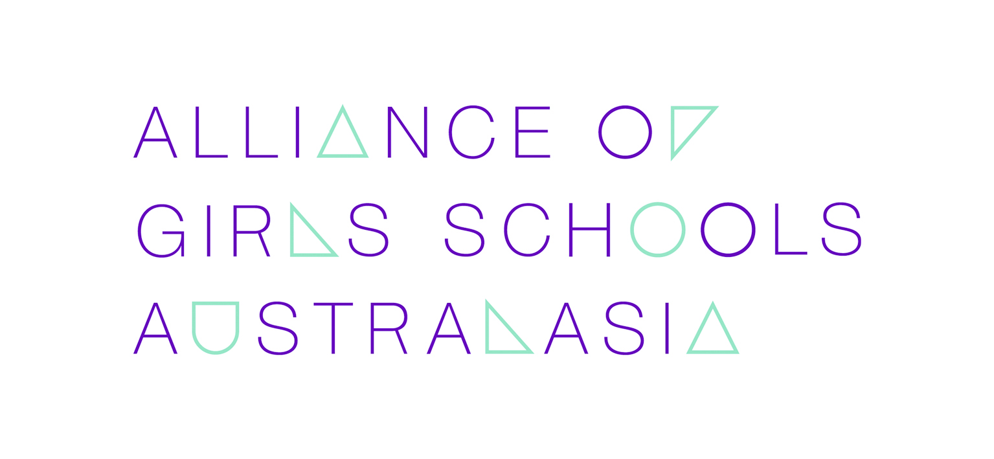

ANNUAL GENERAL MEETING 2022
The Alliance of Girls’ Schools (Australasia)

ANNUAL GENERAL MEETING ATTENDANCE FORM

NAME OF SCHOOL:

NAME OF PRINCIPAL:

☐WILL ☐WILL NOT

be in attendance at the Annual General Meeting at 2.30 pm (AEST) Monday 16 May 2022

☐In-person ☐via video conference

IF YOU WISH TO APPOINT A PROXY PLEASE COMPLETE THE PROXY FORM BELOW

PROXY FORM

PROXY FORM
I (PRINCIPAL) ………………………………………being a member of the Alliance of Girls’ Schools (Australasia) Ltd and being entitled to 1 (ONE) vote, hereby appoint

NOMINEE …………………………………..PRINCIPAL of (NAME OF SCHOOL)
as my proxy to vote on my behalf at the Annual General Meeting of the Alliance of Girls’ Schools (Australasia) Ltd to be held on the 16th day of May 2022.

Signature:

PLEASE RETURN BY 5.30 pm (AEST) 13 May 2022 TO agsa@agsa.org.au

Questions from Members

Members who are unable to attend the AGM, or who prefer to register questions beforehand concerning matters to be considered at the AGM are invited to do so.

Please submit questions via email to the Executive Officer, Alliance of Girls’ Schools Australasia, at agsa@agsa.org.au or by mail to PO 139 Tugun, Queensland 4224, Australia or email to by 5.30 pm (AEST) on 6 May 2022.

