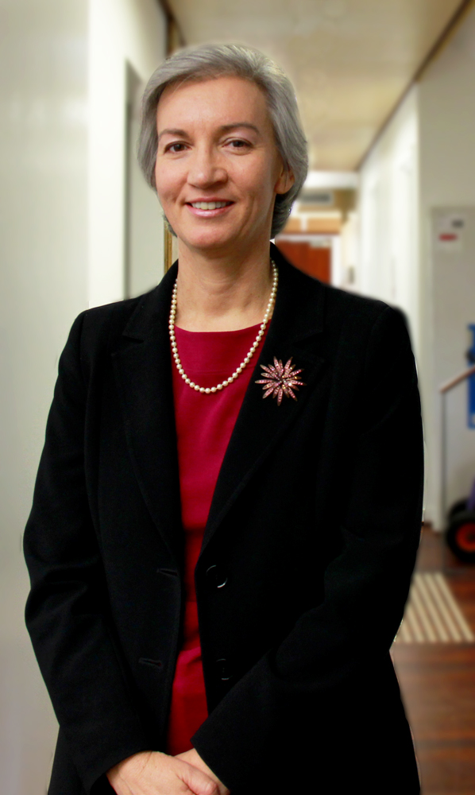
Dr Corinne Jones

Dr Corinne Jones MBBS (WA) FRACS FRCS (England) is a general surgeon with supra-specialist training in breast and thyroid surgery. Her extensive training and experience have been both in Australia and overseas.

Dr Jones obtained her medical degree in 1989 at UWA. She trained to be a general surgeon over the next 10 years in major teaching hospitals across Perth, including the breast clinics at Royal Perth and Sir Charles Gairdner.

In 1999, having gained her Australian General Surgical Fellowship, Dr Jones travelled to Scotland to undertake two years of post fellowship training in breast & thyroid surgery. In 2002 she became Director of the Breast Service at Pilgrim Hospital, a National Health Service (NHS) hospital in Boston, England. In 2003, taking 12 months leave from Pilgrim Hospital, Corinne completed a Thyroid Surgery Fellowship in France.

On returning to her position as Director of the Pilgrim hospital Breast Unit in Boston, she also established a dedicated Thyroid/Parathyroid Service. Both services were highly successful in achieving NHS targets for recommended standards of care. Dr Jones is a Fellow of the Royal Australasian College of Surgeons and the Royal College of Surgeons of England.

Dr Jones returned to Perth in July 2008 and worked in the Breast Centre at Sir Charles Gairdner Hospital until December 2009 and consulted at Mercy Hospital, formerly St Anne’s Hospital, until September 2011. She is now full time at St John of God Hospital in Subiaco and runs a private practice dedicated to breast and thyroid patients and is closely involved in developing a world class Breast Cancer Service at the hospital.

